Logistic Regression Real Life Model in Python:

Problem Statement: To check whether a person will buy a particular car or not.(1-He buys,0-He doesn’t buys)

Data Set: We have used User-id, Gender, Age, Salary and Purchased.

I have extracted this tabular set of data from the internet:

Data Set/Training Set used to predict the price:

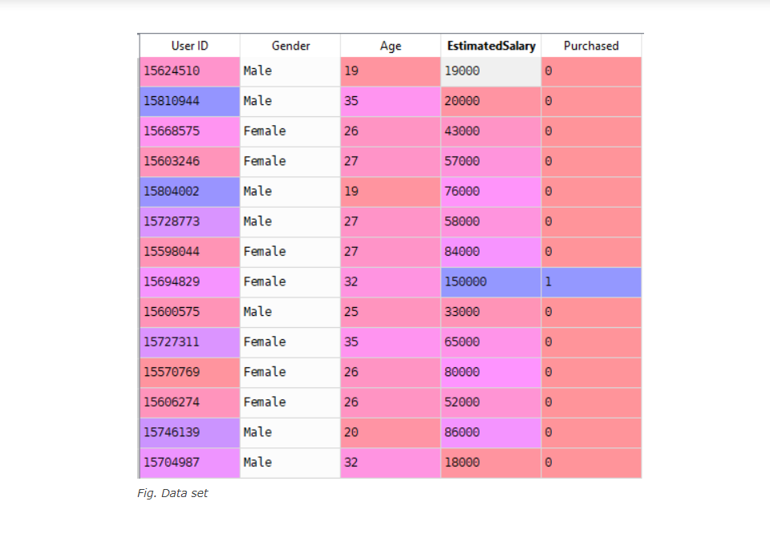

From this particular training set we are predicting whether a particular person will buy the car or not and I am plotting that just like I am plotting the training set.

Training set(Graph):

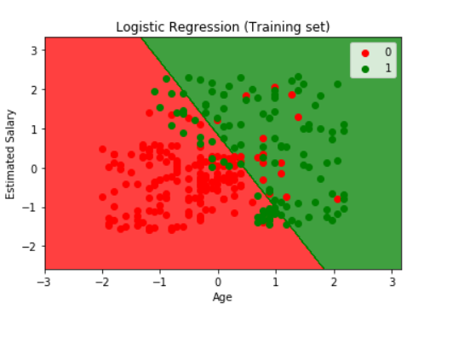

Test Set(Graph):

